# Kimani Muhammad

10/16/2025

# CS 255 System Design Document

## UML Diagrams

### UML Use Case Diagram

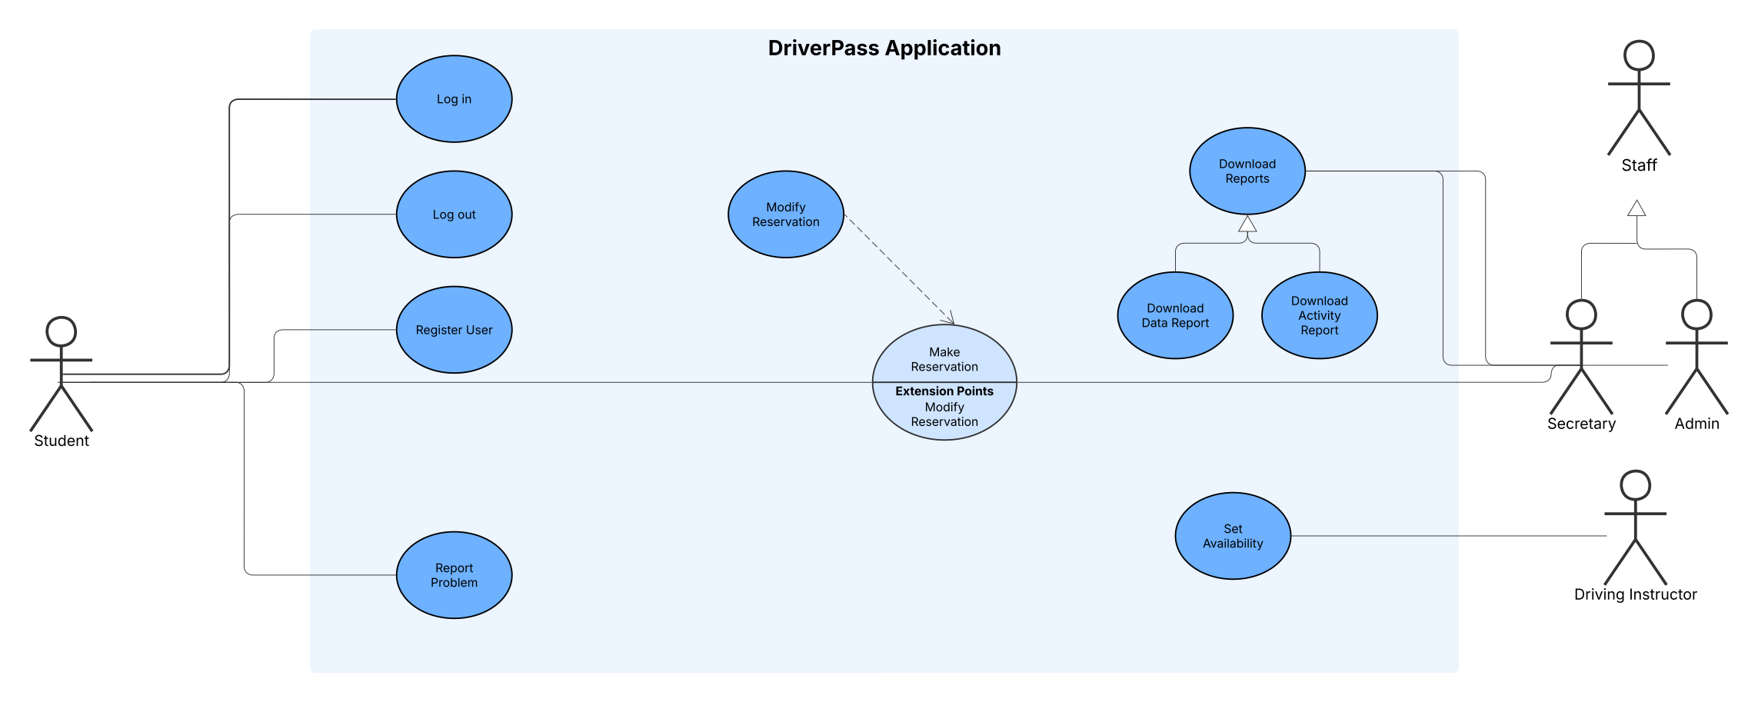

### UML Activity Diagrams

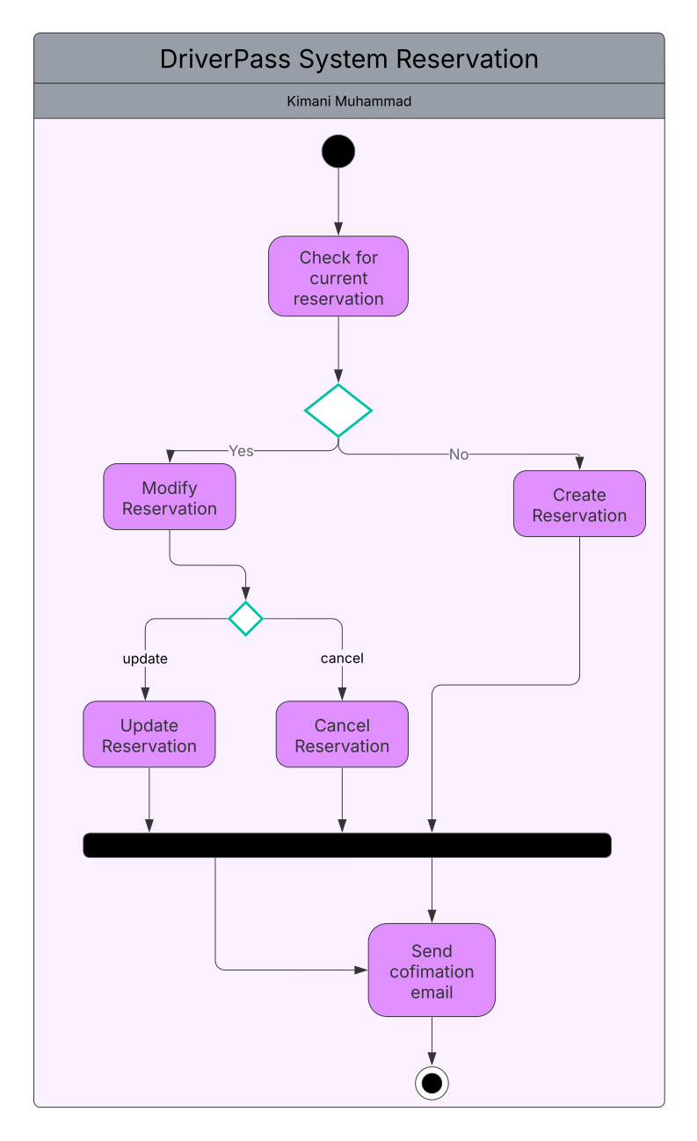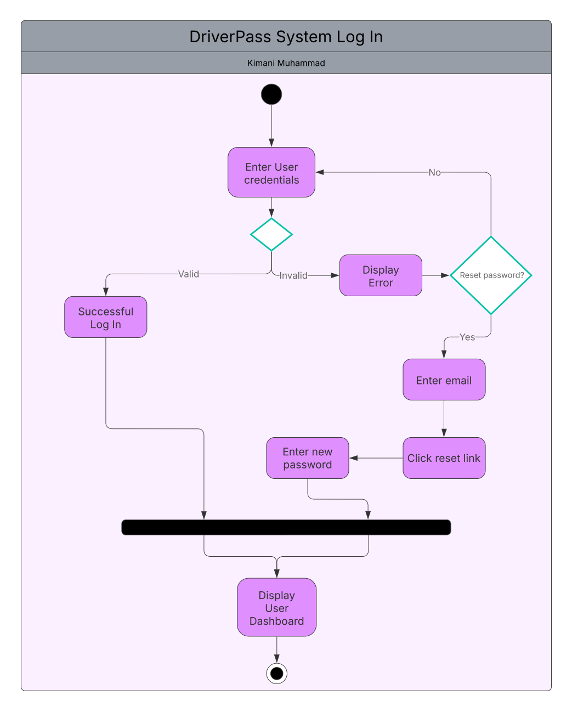

### UML Sequence Diagram

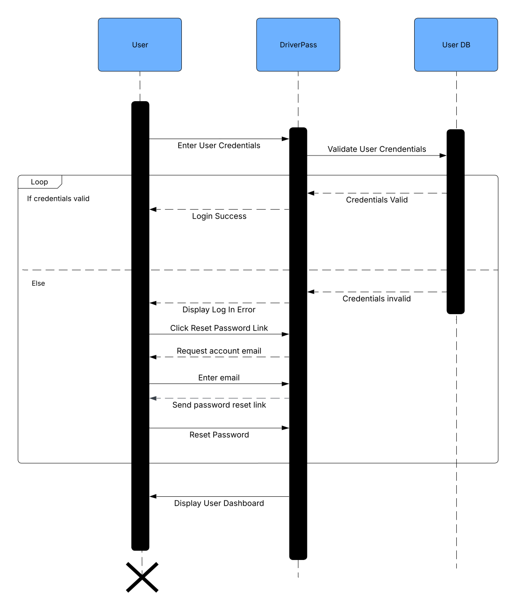

### UML Class DiagramDriverPass UML Class Diagram.pdf

## Technical Requirements

This is a web-based system that runs on modern web browsers including Safari, Chrome, Firefox, Microsoft Edge, as well as Android and iOS. Interactions should ideally be complete within 300 ms to ensure responsiveness and encourage user engagement. The system should be regularly updated with security patches and bug fixes to protect sensitive data and maintain reliability. It should support Windows, Chrome OS, and macOS to accommodate the variety of devices students use. The backend API will be developed in a stable, supported version of Java and Spring Boot, hosted on a Linux-based AWS instance to ensure scalability and cost-effectiveness, with a load balancer to handle traffic surges and enhance reliability. A relational database (Amazon RDS) will store user, staff, and reservation data, integrated with the backend API using Spring Data JPA, while generated reports will be stored in Amazon S3. The frontend should be developed in React using JavaScript to provide a component-driven, responsive user interface. Development and collaboration will be managed using Git, Bitbucket, Jira, and an integrated development environment such as IntelliJ.